Applying the Model-View-Controller Design Paradigm
in VisualAge for Java

by Scott Stanchfield

The Model-View-Controller (MVC) design paradigm is an incredibly useful tool in writing maintainable programs. MVC lets you separate your business logic from your Graphical User Interface (GUI), making it easier to modify either one without affecting the other. Initially, MVC requires a little extra planning and coding, but the long-term benefits are well worth it.
When MVC was first publicized, visual composition tools were limited in capability and not nearly as popular as they are today. The visual composition tools of today, such as the VisualAge for Java Visual Composition Editor (VCE), support true visual programming, enabling you to visually create much of an application's GUI and business logic.
Unfortunately, this kind of simple visual programming has eroded solid design techniques. Many developers simply sit down at their desk, open the VCE, and start clicking the mouse. Rather than thinking through GUI and application designs, they experiment. Eventually they get things to "look right," then draw lines to "make the application work."
This article discusses the MVC design paradigm and demonstrates its application in visual programming. Keep in mind that MVC is but a single technique in a developer's design arsenal, and should be used in combination with other techniques, including object-oriented analysis and design.

What is MVC?
The MVC paradigm was introduced by Smalltalk developers at Xerox PARC (Palo Alto Research Center) in the late 1970s. The basic idea is to split your application into three distinct parts, each of which can be replaced without affecting the others:
- Model – the data of your application, along with the business logic that defines how to change and access that data. The model can be shared among any number of view and controller objects.
- View – The means of presenting the model’s data to the outside world. This could take the form of a GUI, generated speech, audible tones, printouts, or even non-user oriented output, such as turning on an air conditioner.
- Controller – The means of gathering user or other environmental input and providing feedback to the model, normally changing some of the data in that model.

Interaction Between Components
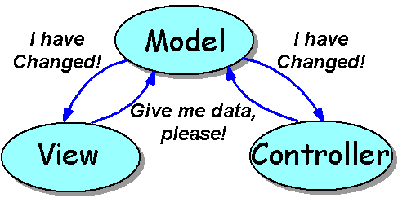
Let’s examine the interaction between these three pieces. Initially, the view, and possibly the controller, ask the model for its current state. The view may present data to the user, and the controller may check the data to help decide how to handle user interaction.

Figure 1 Model and user interface communication

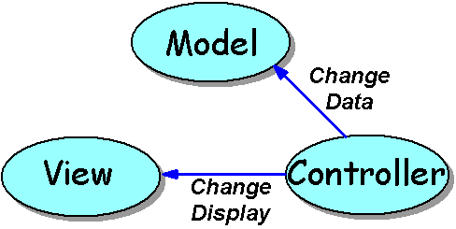
As seen in Figure 1, the view and controller will typically "listen" for changes to the model. The Java language implements this notification using events. Whenever the model says "I have changed," the view and controller can ask for the new state of the model's data, then update their presentation to the user.

Figure 2. Controller to model communication

Figure 2 shows user interaction in the application. If the user decides to interact, the controller takes charge. It watches for user input, such as clicking or moving the mouse or pressing keyboard keys. It decides what the interaction means, and asks the model to update its data and/or the view to change the way it displays the data.
For example, you could have a view that displays a set of data in a Swing JList component. You add a scrollbar as a controller, which directs the view to change which items are displayed. Further, you could add another controller, perhaps a Swing JTextField, to take user input and ask the model to add the new value to the set. Of course this would cause the model to shout "I have changed!", to which the view responds by asking for the set of data.
The above scenario has two controllers. One watches for mouse interaction with a scrollbar, while the other accepts user input to add to the model. You can have any number of controllers, and any number of views in your application.
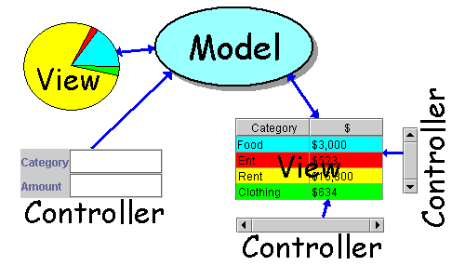
Suppose you have an application that presents information from a database in a table and pie chart. The table can be scrolled using horizontal and vertical scroll bars, and new data can be entered via a pair of text fields. The MVC pattern might be applied as shown in Figure 3.

Figure 3. Multiple views and controllers

This example includes a model, two views and three controllers. The scrollbar controllers update only the table view, while the text field controller updates the model.

Delegates -- Combining View and Controller
You may be concerned at this point about separation between the scrollbars and the table they scroll. In theory this separation is good, but in practice it can make life much more difficult:
- You need to separate the GUI among multiple VCE sessions, and provide promoted variables and events to communicate between the controller GUI and the view GUI
- Where does an AWT TextField go? It acts like a view to display existing data, and like a controller to change the data.
- Many components have built-in support for user interaction such as scrolling.
- Interaction between multiple controllers and views can be quite heavy and complex.
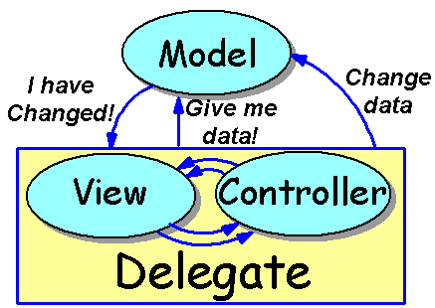
Because of such issues, the MVC paradigm is often simplified by combining views and controllers. There are several names for this approach -- this article uses the name delegate to refer to a combined view/controller. (This is the term used by Sun in describing the Swing GUI components.). This combination into a delegate is shown in Figure 4.

Figure 4. Combining view and controller into a delegate

In a delegate, the view and controller communicate as necessary to perform their duty. It is a good idea to keep this communication separate when possible, but often it's impossible to break a component into a view or a controller. And, in practice, the separation doesn't provide nearly as significant a benefit as separation of the Model and Delegate.
The delegate as a whole communicates with the model in the same way described earlier for the view and controller. The separation between the model and the user interaction of the delegate is the key to the success of this model. Although this version of MVC is somewhat simplified by the combination of the view and controller into the delegate, the design is still MVC-based. You can use it to create some interesting and very flexible applications in VisualAge for Java.

Why is MVC So Important?
By this point you may be thinking, "Sounds like neat theory, but it also sounds like a lot of work!" You're right on the first point, but as you'll see later, implementation in VisualAge for Java is actually very easy! Another question might be "Why is MVC so important that Scott would take the time to write this article?" Development typically occupies 10% or less of a program's life cycle. Therefore, program maintenance should be a developer's number one concern. A clean, understandable design is a good start, but to be really effective, the design should separate business logic from user interface.
Think about some of the possible ways a program changes over time:
- The current state of GUI design evolves, and a company decides to update their GUIs. (Often this is referred to as "making the GUI look more professional.")
- A company changes network architectures, and wants to port their applications.
- A company decides to create a limited-feature demo of their application.
- A company wants to add a new way of examining existing data.
Changes like these often involve either the GUI or the business logic of an application. If the GUI code and business logic are tightly coupled, making these changes can be quite difficult. Using an MVC-based design makes the changes less extensive, and more importantly, more isolated, reducing the chance of introducing bugs in unrelated code.
Using an MVC-based design, the above changes are fairly simple:
- Updating the GUI requires only changing GUI code. The stable business logic is not touched.
- Updating network architectures, perhaps changing from a two-tier to a three-tier database architecture requires modifying only part of the model. The stable GUI is not touched.
- Creating a limited feature demo might merely be a matter of subclassing the model to block access to some features. Again, no change to the GUI.
- Adding a new way to examine data is simply a matter of adding a new view. Often no change to the model is necessary, nor is it necessary to change other views!
A final thought on the importance of MVC: by separating the business logic from the GUI, you can also separate the coding tasks. Separate developers can work on each part -- a GUI specialist coding the GUI and a domain expert coding the business logic.

Implementing MVC in VisualAge for Java
Note: This article assumes VisualAge for Java, Version 3.0. The techniques explained will also work with VisualAge for Java 2.x, but you cannot use the Quick Form support to create your GUI.
Now that we've laid out the concepts and rationale, let's look at implementation details by walking through a simple address book application. Being good MVC designers, we decide to split the application into models and delegates. We design the application with a two-level model:
- Address Book -- A model that stores a collection of addresses. The interface that defines this model requires methods to add and look up individual address records.
- Address Data -- A model that represents a single address record. Many of these will be stored in an Address Book.
We choose this two-level model because it helps show that MVC can be applied at many levels in an application. You can use MVC when creating GUI components (such as Sun's Swing components), as a good division of labor for your entire application, or at any level in between. Models can contain references to other models and delegates can contain references to other delegates.
To understand the creation of this application, you can break the design into four phases:
- Define a model interface -- Define how the model and delegate communicate. Defining a protocol (or contract) between them is best represented in Java by writing an interface class.
- Define concrete model(s) -- Implement the interface to create actual model classes for use in an application.
- Create delegate(s) -- Create a delegate (GUI) class that has a variable of the model interface type. The GUI can communicate with the model, and any model class that implements that interface can be plugged in at run time.
- Connect as an application -- Finally, create an application by simply connecting one or more delegate classes with a concrete model class.
We will create a concrete model that stores the data in a hash table, but the actual data location does not matter. In part 2 of this series, we implement filtering and sorting models and discuss how you can use data from other sources, stored in data bases or on other machines.

Defining a Model Interface
The first step in defining an MVC application is to define how your model and delegate will communicate:
- How will the model inform the delegates that it has changed?
- What data can the delegates obtain from the model, and how do they access it?
- What data can the delegates request be changed, and how do they request it?

Model-to-Delegate Change Notification
Several issues are involved with change notification. The first and most important is the granularity of the notification. You can notify at several levels. For example:
- You can fire an event that says "something's changed," without giving details. The delegate then needs to examine all the data to determine what has changed. This is effective if the delegates will normally need to reread all the data after any change. For example, Swing provides a generic ChangeEvent for just this purpose.
- You can simply use JavaBean bound properties as the available data in your bean. PropertyChangeEvents are fired any time one of the properties changes, which effectively limits the scope of the change notification. This approach works well when you have a one-to-one correspondence between properties and the GUI components that represent them to the user.
- You can create a custom event class and listener interface that captures specific information about the nature of a change. For example, Swing's TreeModel fires a TreeModelEvent to its TreeModelListeners. The TreeModel can be more specific about the type of change, telling its listeners that nodes were added or removed from other nodes, structure has changed for some subtree, and so forth. This allows the delegate to update its presentation more efficiently; if the updated area doesn't affect the current display, nothing changes.

Bound Properties and GUI Components
We can take advantage of the JavaBean specification's definition of bound properties to assist in creation of our models. Bound properties are properties that fire a PropertyChangeEvent any time their value changes. We can use this as the "I've changed" notification from our model.
We can also take advantage of bound properties in our GUI components. VisualAge for Java provides excellent support for bound properties in the form of property-to-property connections. Two bound properties connected via a property-to-property connection will update each other's values when they change.
Assuming we have bound properties in the model and in the delegate, much of the communication between a model and a delegate can be accomplished through a property-to-property connection!
The problem is that Swing and AWT do not bind properties that should be bound. For example, TextField does not bind its text property. Fortunately, we'll be using the Quick Form dialog in the VCE, and that makes dealing with changes in a TextField easy. For Swing components, however, we would need to create a BoundJTextField. For a discussion on how to do this, see Binding a Non-Bound Property at the VisualAge Tips and Tricks site. Note that this article will be using a TextField.

Making Things Easier in VisualAge
VisualAge for Java provides excellent tools for developing classes, but not much support for developing interfaces. The above four-step process assumes we define the interface first, then implement that interface with concrete classes. Because we're using bound properties in our model, it would be much easier to start with a concrete model. The BeanInfo editor in VisualAge for Java provides a very easy way to define a bean with bound properties. We will use the BeanInfo editor to flesh out a concrete model, then create a model interface based on that concrete class.
Once we have the interface, we can implement any other models we like and plug them into our application.
To create this interface, you can use the AutoGut tool, a plug-in for VisualAge for Java. AutoGut examines a class and creates an interface by "gutting" the methods from that class. We'll walk through the use of AutoGut in a moment, but first you need to download and install the tool. You can get AutoGut from http://www.javadude.com/tools/autogut. Follow the instructions on that page to install the tool.

นำมาจากส่วนหนึ่งใน website
http://www7.software.ibm.com/vad.nsf/Data/Document2672

